Photo Contest Details and Description (for Social Media Posts and OE3C Website)

Website Description
OE3C 2026 Photography Contest 📸
If you’re attending OE3C 2026 and enjoy taking pictures as you coexist within nature, you’re encouraged to participate in our Photography Contest!
Enter for a chance to display your skills and win a prize pack full of fun Niagara and nature-themed goodies. More details on prize packs coming soon.
Attendees can submit one photo in each of the following categories:
- Ecology
- Ethology
- Evolution
- Methodology (fieldwork)
- Landscape
- Close-Up
Anyone in the public is welcome to vote on their favourite picture in each category, so be sure to share the contest link with your friends!
Submissions are now open until May 1st at noon, and voting will be open April 30th to May 1st. Winners will be announced on the last day of the OE3C. Photos submitted will be displayed throughout the Colloquium and the winning photos will be shared on our social media channels.
Scan the QR code to go to the contest page for submissions, voting information, as well as other contest details and deadlines. Terms and conditions apply.
Link: https://pollunit.com/en/polls/oe3c2026
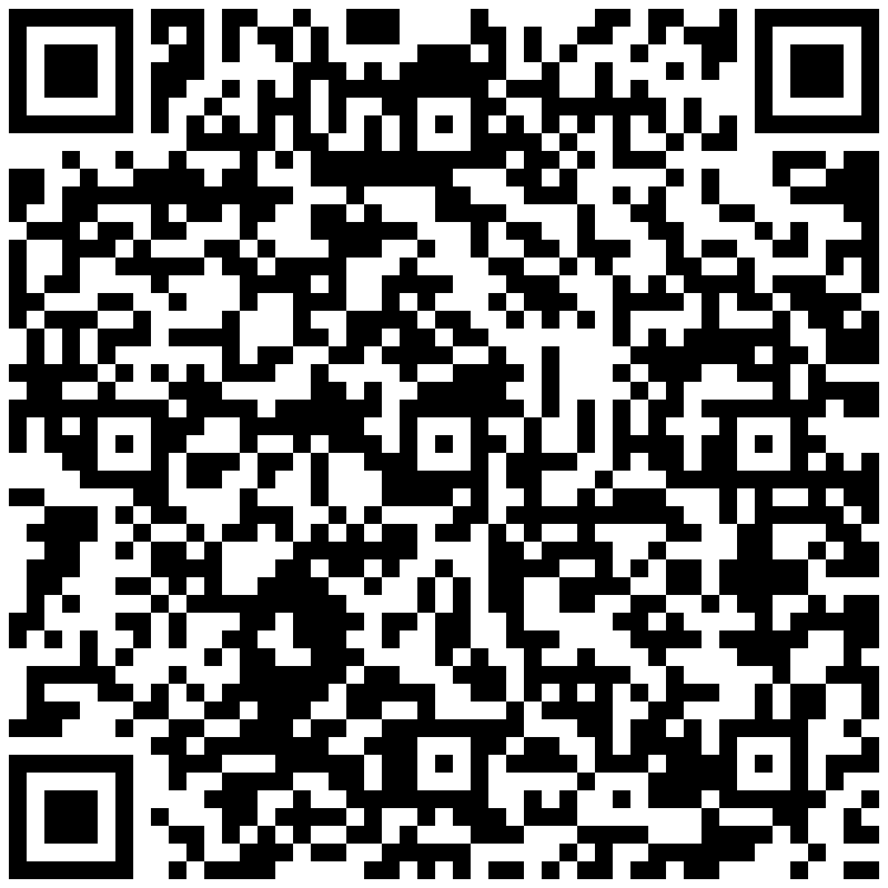

Social Media Posts
Introductory Post:
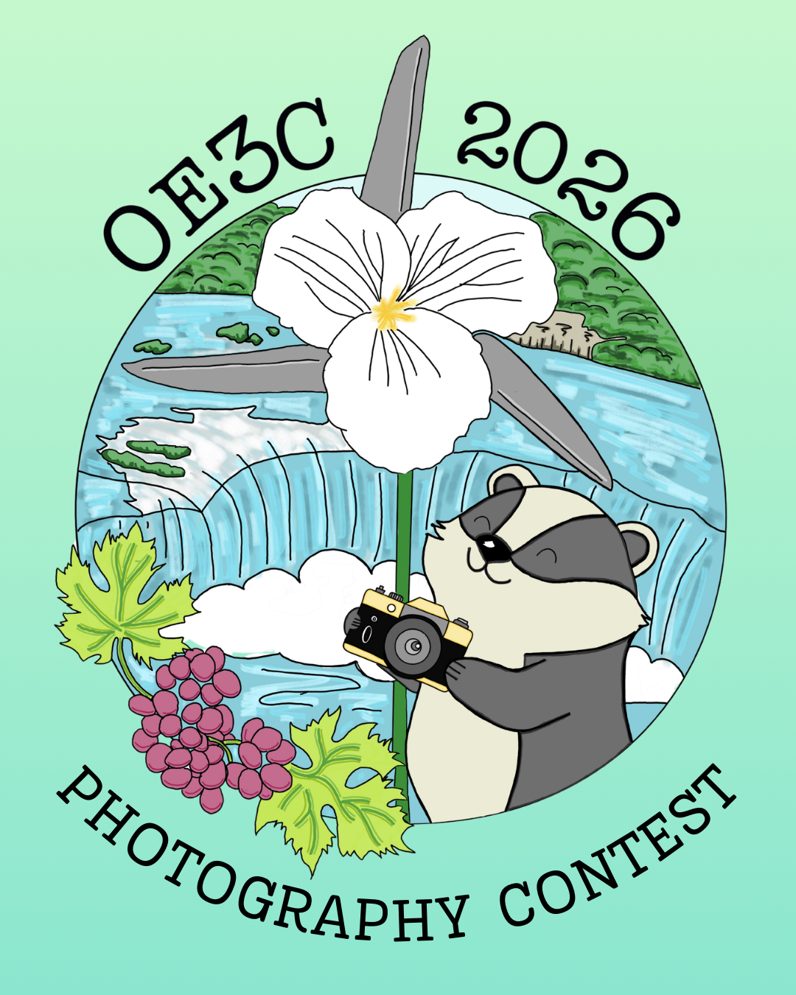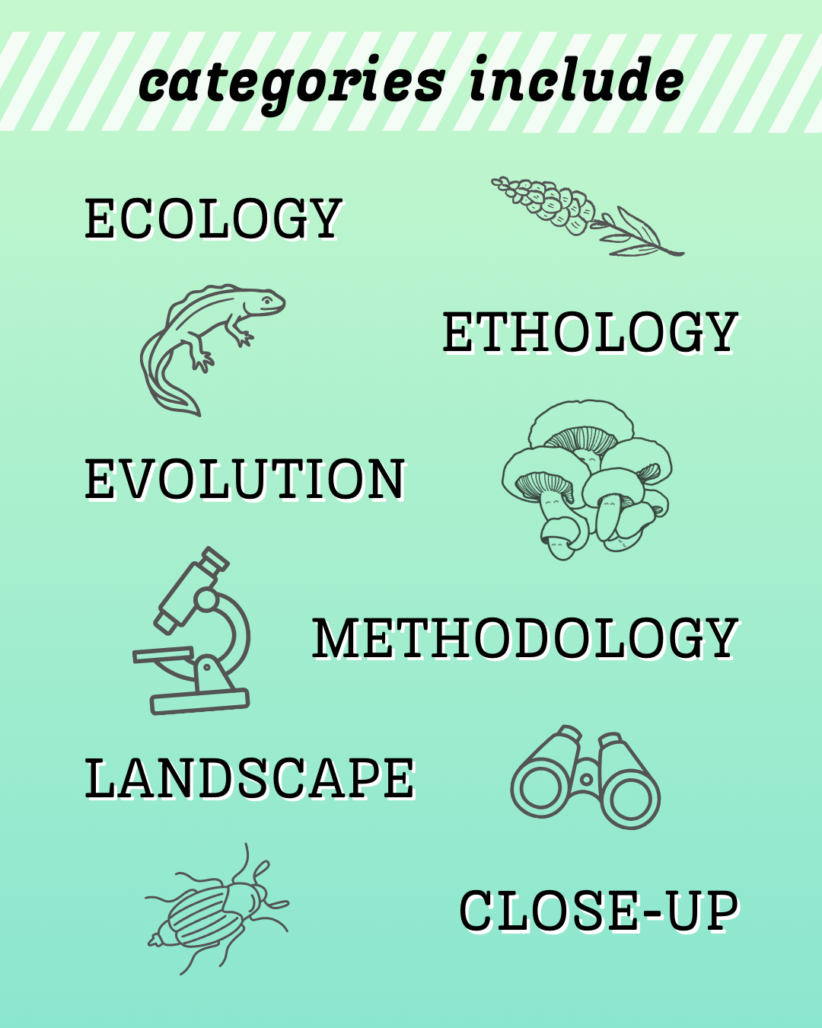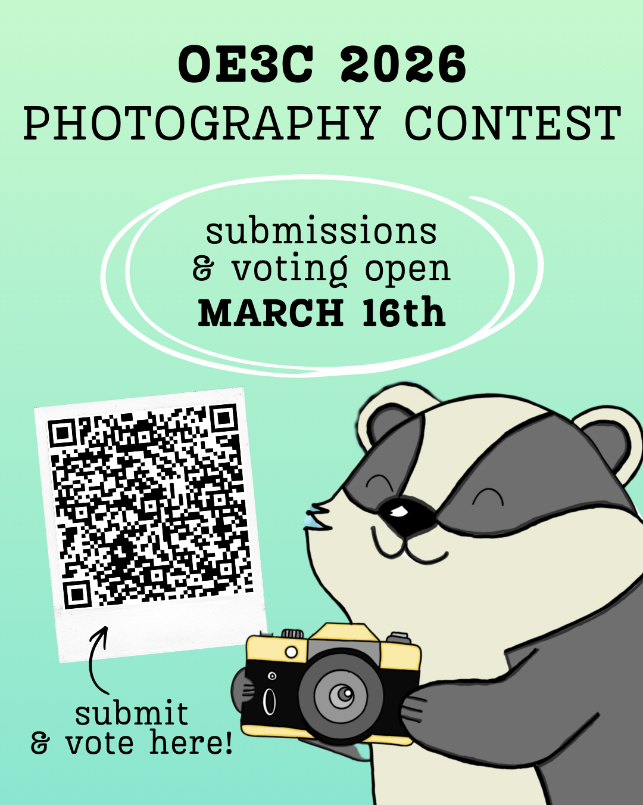
Calling all professional or amateur photographers 📢
If you’re attending OE3C 2026 and enjoy taking pictures as you coexist within nature, you’re encouraged to participate in our Photography Contest!
Enter for a chance to display your skills and win a prize pack full of fun Niagara and nature-themed goodies. Each attendee can submit one photo in each of the following categories:
Ecology • Ethology • Evolution • Methodology • Landscape • Close-Up
Anyone is welcome to vote on their favourite picture in each category!
Submissions are now open until May 1st at noon. Voting will take place April 30th to May 1st, and winners will be announced on the last day of the OE3C. Photos submitted will be displayed throughout the Colloquium and winning photos will be shared on our social media channels.
Scan the QR code to go to the contest page for submissions, voting, as well as other contest details and deadlines (or see link in bio).

Reminder/Prize Pack Post:
TBD
Last Call Post:
TBD

